**a)**

simulator keys: <tname, col, row>

schema keys: <tname, col>

**b)**

The attributes <tname, col> of table simulator references the attributes <tname, col> of table schema

**c)**

contents of simulator:

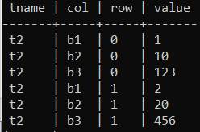

contents of schema:

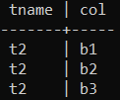

**d)** (code)

**e)** (code)

**f)**

contents of simulator2

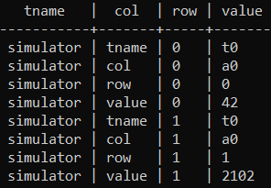

**g)** (code)